USE CASE:

**1. Use-Case Name – Generate Street Academy Enrollment**

**1.1 Brief Description**

The Parent/Guardian, Program Assistant, or Youth Specialist enrolls student into the Street Academy Program.

**2. Flow of Events**

**2.1 Basic Flow**

1. The use case starts when a Parent/Guardian wants to enroll their child into the program.

2. If Parent/Guardian decides to enroll online

2.1 The system requests youth demographics, parent/guardian information, and additional youth information.

2.2 The Parent/Guardian provides the youth demographics, parent/guardian information, and additional youth information.

2.3 The system records the youth demographics, parent/guardian information, and additional youth information.

3. If Parent/Guardian decides to enroll on-site

3.1 Program Assistant/Youth Specialist requests youth demographics, parent/guardian information, and additional youth information.

3.2 The Parent/Guardian provides the youth demographics, parent/guardian information, and additional youth information.

3.3 The Program Assistant/Youth Specialist inputs into system youth demographics, parent/guardian information, and additional youth information.

3.4 The system records the youth demographics, parent/guardian information, and additional youth information.

4. Use case ends

**2.2 Alternative Flows**

None.

**3. Special Requirements**

None.

**4. Pre-conditions**

**4.1 Pre-condition**

The Street Academy Program has been created within the system.

**5. Post-conditions**

**5.1 Post-condition One**

The enrollee’s information has been recorded.

**5.2 Post-condition Two**

The Parent/Guardian receives confirmation their child has been enrolled, along with a schedule of the program.

**6. Extension Points**

**6.1 Name of Extension Point**

Extend: Update existing youth demographics, parent/guardian information, and additional youth information.

USE CASE DIAGRAM:



SEQUENCE DIAGRAM:



CLASS DIAGRAM:

 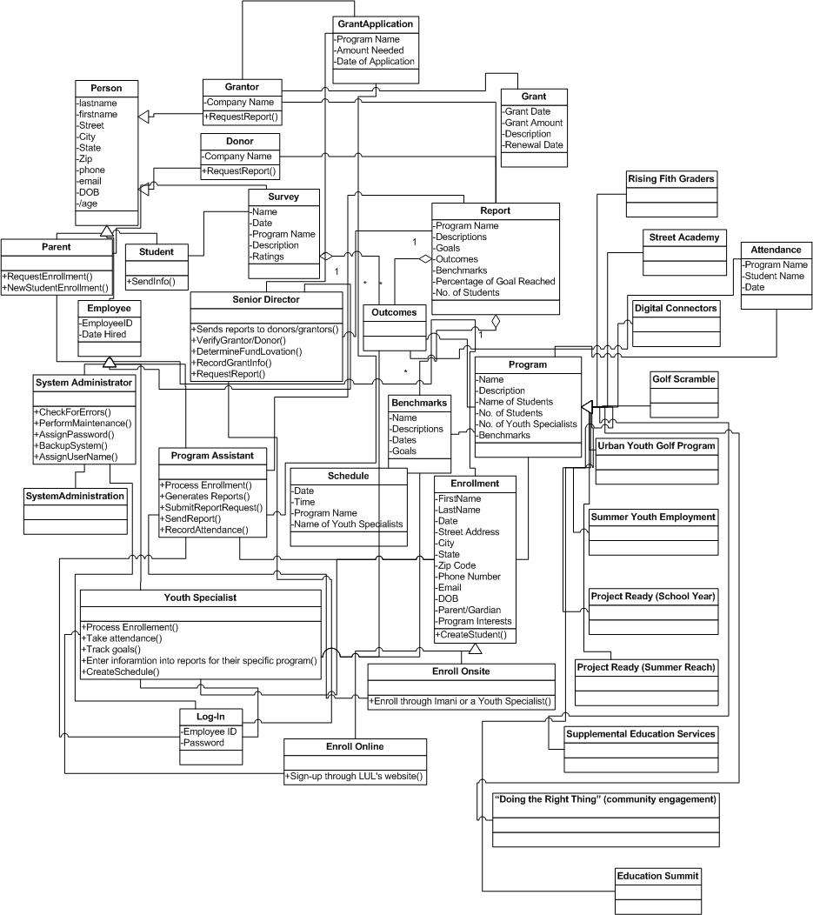

ERD:



USER INTERFACE NAVIGATION:



GANTT CHART:

